SAMYUKTHA RAJ-

PROGRESS REPORT[17/12/2018]-

Completed the first out of the five courses on python(offered by University of Michigan) and finished week three of the second course, and week two of the ML course(by Andrew NG). Relevant codes of the python course one are also attached.

MULTIVARIATE LINEAR REGRESSION-

Linear Regression with multiple variables is known as multivariate linear regression.

A slightly different set of notations are now used as there are multiple number of variables(features).

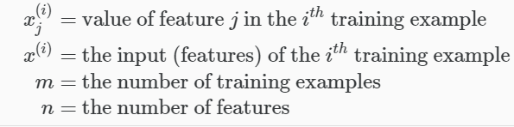

The hypothesis function is now modified as-



It can be represented using matrix multiplication as-

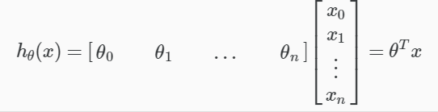

GRADIENT DESCENT FOR MULTIPLE VARIABELS-

The algorithm can be represented as-

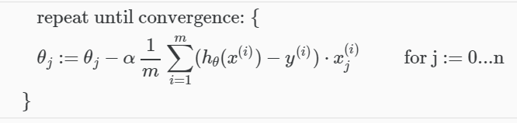

NORMAL EQUATION-

It is another method of minimizing the cost function but without the large number of iterations and also in a simpler way(given that m is not less than or equal to n)



NON-INVERTIBILITY OF XTX-

There are two main causes-

1-Redundant features, where two features are too closely related making them linearly dependent and thus redundant.

2-Too many features.